How to Map Users ( For WABA API numbers ) in HubSpot Integration
This guide provides step-by-step instructions on how to link your WABA API numbers to specific HubSpot users. Successfully mapping users ensures accurate data synchronization and efficient workflow management between your platforms.
Navigate to the Integrations Page
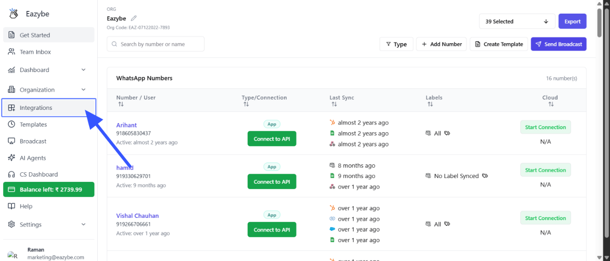

Access HubSpot Integration Settings
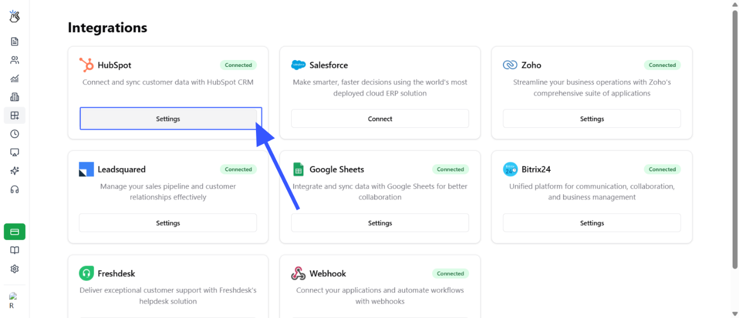

Select the User Mapping Tab
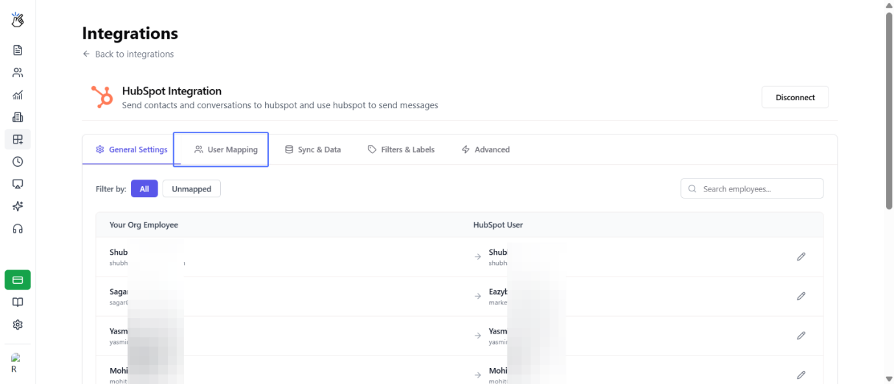

Choose a HubSpot User to Map for a WABA API Number
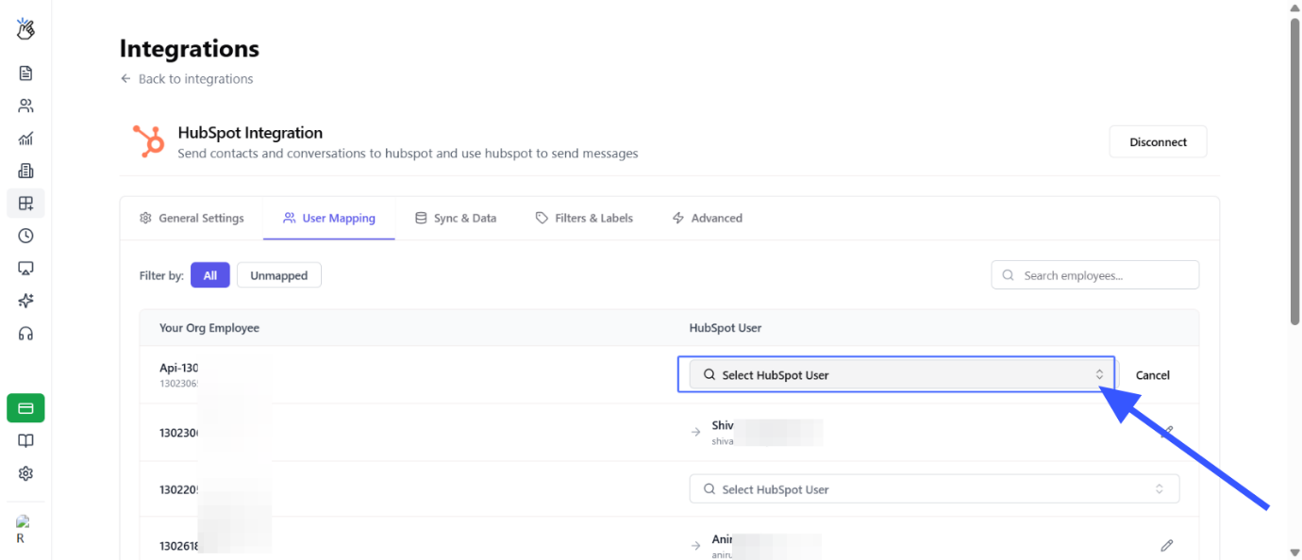

Select the Specific HubSpot User
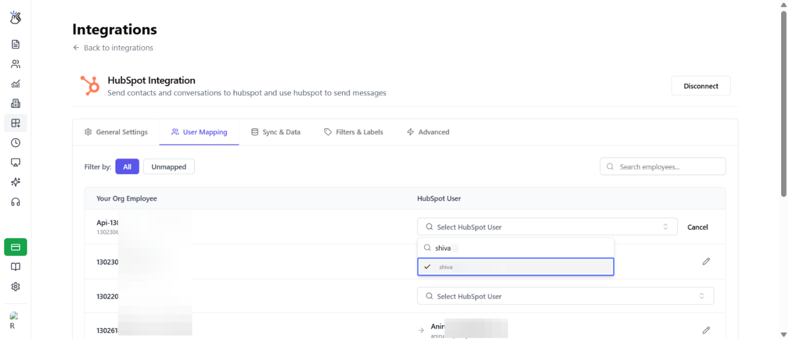

Verify Successful User Mapping
